Cad Cam Links / Arden
I have a few more hours of development to complete the changes I want to implement. I hope to wrap this up by the end of the week. We also need ASI to test the files I created during my visit and give their feedback. This is comprised of two (2) XML files and eight (8) JPG image files.
• XML files are located at \\PS2\PS2 Shared Folder\Impact Shared\Export\XML
• Image files are located at \\PS2\PS2 Shared Folder\Impact Shared\Export\Images
I will keep you posted when I have a new plug-in to install. If all goes to plan, maybe we can do some testing on your system mid-next week.
Excellent news on the customers! That is excellent progress.
Regarding using the template for specs, you need to check with ASI. They hold all of the information and we are sending them the CAD information along with a picture of the CAD file. ASI will be in charge of printing all specs.
This is exactly opposite of how the HRMS link worked. HRMS sent Impact all of the information and Impact printed the specs.
Duane- for every customer built into ASI, we are assigning it in impact. As of today, any new customer’s being built in to ASI whether old or new, will be entered in both systems. We should have this done by this afternoon. (Item #1 to do list)
Since you were unavailable on Friday when I finished up at your facility, I want to provide a detailed update of what I accomplished during my visit. I also have included the tasks that need to be completed moving towards your go-live date of April 1st.
Normalize Database
The biggest task of this visit was to normalize the Impact database with the new ASI data provided by Sherry. This data was exported from ASI into an Excel spreadsheet. Impact has 65,000+ existing projects that are assigned to customers, styles, joints and board grades that are incompatible with ASI. These all need to be remapped to ASI data while still allowing the link with HRMS to continue to function. This allows for Impact to be tested with ASI while the HRMS link runs in parallel.
1. Customers – I remapped a few customers simply for testing. Most of the customer names in Impact (HRMS) do not exactly match ASI. Someone at Packaging Specialties needs to add the ASI customer codes to the Impact customer database. See #2 in the next section “Excel – Impact ASI Master Sheet”
2. Styles/Joints – I was able to normalize most of the Impact style/joint codes to the equivalent ASI style code. The exceptions to this were “Partitions“, “Display Base“, “Display Part“ and “MIsc”. ASI has a 128 variations of a partition style where Impact has 1 called “Partition”. In these cases, I left the ASI style blank. Designers can manually assign these to the correct ASI style on an as needed basis as they open/work on these legacy designs. The Impact projects containing an unassigned style equated to 2694. See “4-LEGACY STYLES-JOINTS” of the next section “Excel – Impact ASI Master Sheet” Note: the Impact style/joint “RSC 2PC Stitched In” did not have an ASI equivalent, and therefore was not mapped to anything.
3. Board Grades – I was able to normalize all Impact projects to an ASI board grade where there was an equivalent. See “6-LEGACY BOARDS-FLUTES” of the next section “Excel – Impact ASI Master Sheet”
In order to normalize the database and allow it to continue to function with HRMS, I added the following tables/fields to your database:
CUSTOM TABLES
• STYLEASI – holds all ASI box/carton styles
• TESTSASI – holds all board/material/tests
IMPACT FIELD NAMES
• CUSTOMER.CS_ADDR6 – holds ASI customer code (can be configured differently in preferences)
• ONE_UP.OU_STYLASI – lookup to STYLEASI
• ONE_UP.OU_TESTASI – lookup to TESTASI
• STYLEASI.S_STYLE – ASI Style Name
• STYLEASI.S_CODE – ASI Style Code
• TESTSASI.T_TEST – ASI Material Name
• TESTSASI.T_CODE – ASI Material Code
EXCEL - Impact-ASI Master Sheet
I have attached an Excel spreadsheet containing the following tabs/worksheets:
1. 1-Customers with ASI Code – this is a small list of 24 customers in the Impact database that have an ASI customer code associated with them. I manually associated these because there was a one to one match in Impact and Advantzware. These should be the only customers we use when testing in the short term
2. 2-Customers MISSING ASI Code – this is a list of ALL of the other customers in the Impact database (mostly created from HRMS). None of these 2490 customers have an associated ASI code. This means the user would get an error in Impact if they tried to submit a project assigned to one of these customers. This needs to happen ASAP as this is one of the highest priorities regarding the Impact side of the integration.
3. 3-ASI STYLES – this is simply a list of all STYLES in the STYLEASI table in Impact. Impact designers will be able to choose from the list of styles once we “switch-on” the functionality. This information is for reference only, there is nothing for you to do here.
4. 4-LEGACY STYLES-JOINTS – this is a list of all of the existing STYLE and JOINT options that exist in Impact for the 65,000+ Impact projects. These style and joint combinations had to be mapped to the equivalent ASI style. I did this during my visit and this tab in the spreadsheet shows my results.
5. 5-ASI TESTS – this is simply a list of all Board Grades in the TESTSASI table in Impact. Impact designers will be able to choose from the list of board grades once we “switch-on” the functionality. This information is for reference only, there is nothing for you to do here. This sheet also displays which ASI board grades were mapped to the legacy Impact projects.
6. 6-LEGACY BOARDS-FLUTES – This shows each of the unique bard grade and flute combinations in the Impact projects. I was able to match these to the equivalent ASI board code. This information is for reference only, there is nothing for you to do here.
Additional Development
During my testing, I identified some specific circumstances where data was not exported to ASI. It was not obvious as to why without digging into the code. I decided it would be much easier to troubleshoot this if there were some detailed logging happening. I plan to add logging to this plugin over the next few days. This will help troubleshoot issues now and in the future more quickly. I will also be making many of the user messages more verbose so it is more obvious what the plugin may be expecting from the Impact user.
Test Files for ASI
I created two test files from Doug’s computer while I was there. This is using ASI data. This is comprised of two (2) XML files and eight (8) JPG image files.
• XML files are located at \\PS2\PS2 Shared Folder\Impact Shared\Export\XML
• Image files are located at \\PS2\PS2 Shared Folder\Impact Shared\Export\Images
On Doug’s computer, \\PS2\PS2 Shared Folder was mapped as the I drive. ASI can take these files for testing purposes.
Handling new additions to ASI and Impact
Currently, there is no automatic link between Impact and ASI regarding data entry. Impact maintains a duplicate copy of the relevant data that must be manually entered. Moving forward, any new styles, boards, customers added to ASI will also need to be added to Impact.
With the exception of customers, we could look at link directly to the ASI style and board grades via a live connection such as ODBC. This is contingent on ODBC drivers existing for the ASI database and our access to them. This is also contingent on ASI allowing direct read-only access to their tables. If possible, we should look into this as a part of a version 2 update to this interface.
TO DO LIST - BEFORE Go-Live Date
While I got a lot accomplished during my onsite visit, there is still more to do. Below is a list of tasks that need to happen before the go-live date.
1. Have your people go through each customer in the Impact database an assign the correct ASI customer code to them (see the “2-Customers MISSING ASI Code” in “EXCEL - Impact-ASI Master Sheet”. This needs to happen ASAP as this is one of the highest priorities regarding the Impact side of the integration.
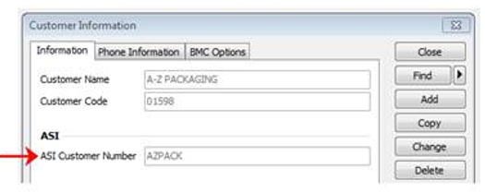
2. Any new Styles (style name and code) added to ASI will need to be manually added to Impact as well. This can be accessed via Database > Custom Tables > ASI Styles
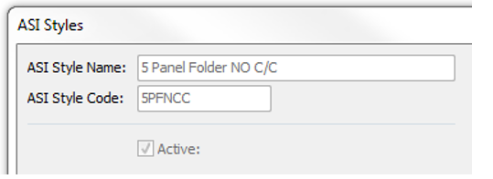

3. Any new Boards (board name and code) added to ASI will need to be manually added to Impact as well. This can be accessed via Database > Custom Tables > ASI Board Grades/Tests

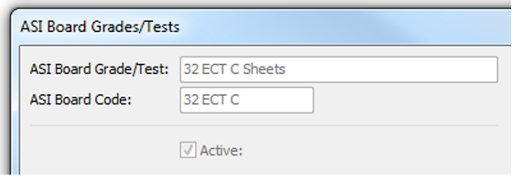
4. Designer Training
a. Filling out DB information
b. Unassigned Styles
c. Panel Scoring
d. Creating Layouts
e. Understanding Error Messages from the Plugin
5. Installing the ASI plugin and Panel Scoring plugin on all Impact Designer workstations (not required for Impact Viewer)
6. Update any Report Templates (spec sheets) to use ASI data
7. Add plugin buttons to the Impact Appearances
8. Update One-Up Database Windows for ALL users (remove legacy fields or make read-only)
9. Database Queries need to be updated to include new fields (and exclude old discontinued fields)
Tables/Fields that will be obsoleted after Go-live
These tables/fields will be obsolete once the switch is permanently made from HRMS to ASI.
• ONE_UP.OU_STYLE – lookup to legacy STYLES (used for HRMS link)
• ONE_UP.STYLE – character field STYLE name (used for HRMS link)
• STYLES.S_STYLE – Legacy Style table (used for HRMS link)
• JOINTS.J_JOINT – legacy JOINTS table (used for HRMS link)
• ONE_UP.OU_JOINT – lookup to legacy JOINTS (used for HRMS link)
• ONE_UP.JOINT – character field JOINT name (used for HRMS link)
Hope this helps clarify everything. We will likely need to schedule another onsite visit closer to your go-live date to finish up the loose ends. It is important we focus on the to-do list in the interim. If you have any questions, please let me know.

